Annual.png

Cambrian Heights

& Rosemont

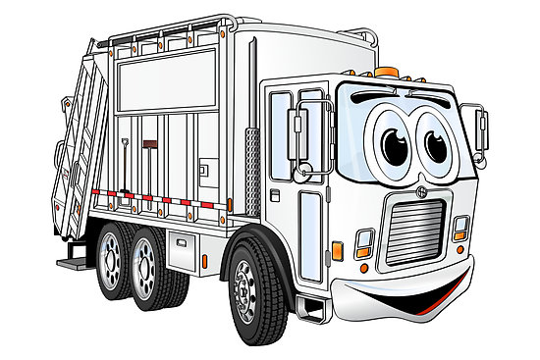

**VOLUNTEERS NEEDED**

**PLEASE SUPPORT YOUR COMMUNITY**

**Call Bent @ 587.433.4576**

**Sunday, May 30**

**Drop Off**

**9:00 am – 1:30 pm**

**Cambrian Heights Community Centre Parking Lot**

**600 Northmount Drive N.W.**

**SPRING**

**CLEAN-UP**

Due to Covid restrictions, you are asked to stay in your vehicle at all times. Your friendly neighbors will then unload for you.

**ACCEPTING:**

* **Household Waste** (City of Calgary)
* **Yard Waste** (City of Calgary)
* **Home Electronics**
* **Home Appliances –** excludingfridges and freezers
* **Car Batteries (not Alkaline)**
* **Metals**
* **Reusable Clothing and Household Goods\*** (Canadian Diabetes Association)

Cambrian Heights and Rosemont Community Associations would like to acknowledge the support of the following City of Calgary Departments:

• Calgary Community Standards

• Waste & Recycling

• Calgary Parks & Recreation

**NOT ACCEPTING:**

* **Propane Tanks**
* **Paint or Household Chemicals**
* **Fridges or Freezers**
* **Liquids (Oils)**
* **Alkaline Batteries**
* **Microwaves**
* **Tires (with and without rims)**